 | Tennis Collectors of America  17th Annual Meeting  October 8-10, 2020  Newport, RI  Agenda | 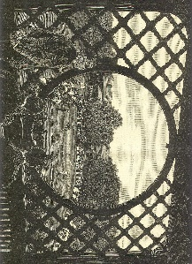

HOTEL –Newport Harbor Hotel & Marina or B&B
Total per night - $264, parking included
Guests may begin reservations by the following two ways:
- Going to www.newporthotel.com and using block code: 2020TENNIS
- Or by using this personalized booking link: Tennis Collectors of America Annual Meeting 2020

SCHEDULE

Thursday, October 8

1:00pm to 5:00pm Tour of museum and collections area
Research in Library – Topic request submitted by August 1 to
markham@tennisfame.com

3:00pm to 5:00pm Play on indoor courts at HOF

6:30 pm Dinner La Forge or on your own Individual pays

Friday, October 9

9:00 am Trip to East Providence – Bus leaves from Newport, hotel
10:00am Indoor Tennis Court - where Tilden played, bring racquet
11:00am -1:00pm Agawam Hunt Club tour, presentation, and lunch
1:00pm Bus leaves Agawam Club for Newport

3:00 pm – 5:00 pm Buy & Sell Show at Newport Harbor & Marina Hotel

4:00 pm – 5:30 pm Play on indoor courts at HOF

6:30 pm Dinner Sardellas or on your own Individual pays

Saturday, October 10

8:00 am Annual Board Meeting at HOF All are welcome

9:00 am Seminars at HOF
Digitization of museum collection
Gorham Silver presentation by RISD Museum
Hall of Famer, Steve Flink speaks about his career

Noon Lunch hosted by and at HOF

1:00pm-- 1:30pm Tour of Casino Theatre
1:00pm – 3:00pm Court Tennis demonstration and lesson
3:00pm -- 5:00pm Play on indoor courts at HOF

6 p.m. Dinner – Newport Harbor Hotel
Social, trivia contest, silent auction, show& tell

March 14, 2020

